Requirements Document for
Mailbird Calendar

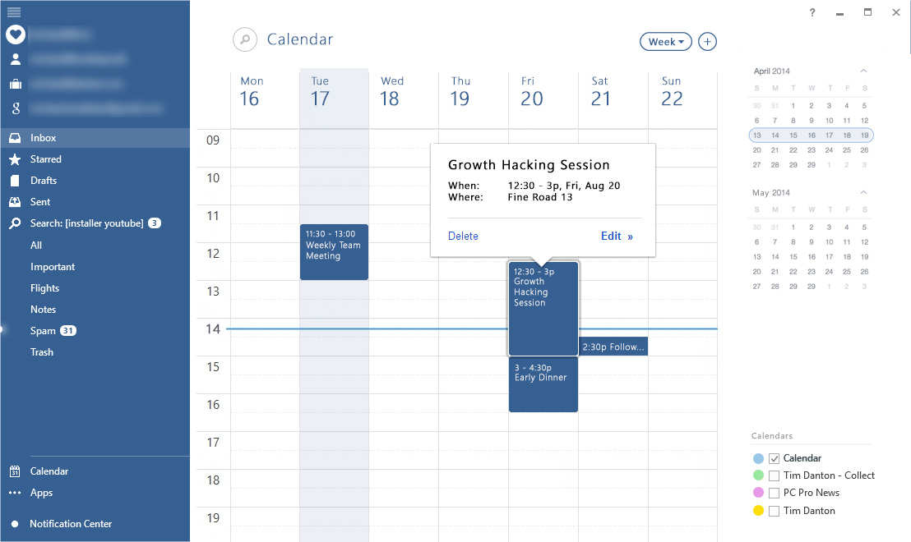

Introduction
Mailbird is a very popular email application for Windows used by thousands and thousands of users all over the world.
The app focuses on email and productivity, and this project seeks to add support for calendar usage as well, as it is a core part of the daily habits of email users.

Executive Summary
A Native Calendar app is the most requested feature currently by the existing Mailbird customers.
Mailbird already provides a web based calendar for Gmail, which works fine, but requires online access. As Mailbird has offline email access and sync, it is expected by our customers that we also provide the same functionality for calendar now.

Application Context
The Calendar will be provided as an app within the Mailbird App Store. People will be able to turn on/off the app.
The app will be developed first as a standalone WPF application, and later integrated into the Mailbird App Framework.

Functional Requirements
The Mailbird Native Calendar provides the following core features:
- Basic calendar functionality
  - Calendar sync with Gmail
  - Local storage for offline support (allow changes while offline – sync when online again)
- Multiple Calendars
  - Support adding unlimited calendars (choose custom color for each calendar)
  - Calendar selector (lower right corner)
    - Show only active/checked calendars
    - When mouse-over, slide up full list of all calendars available
    - When clicking color, provide small color changer popup (Mailbird has a control that can be re-used)
- Appointment invitations:
  - Send appointment invitations
    - Send as .ICS file in email (Mailbird API will be provided to send emails)
    - With auto-suggest people from local contact list (API from Mailbird will be provided later on, just use local storage to begin with)
  - Receive calendar invites via .ICS files
    - Provide API, where Mailbird can submit new ICS files, as they are received via email)
    - accept/reject
- Appointments:
  - Drag and drop and resize to change appointments
  - Click to select appointment
  - Keyboard shortcuts to delete (backspace or del key)
  - To/from time should be shown on each appointment
    - If AM/PM clock is used, then time should look like:
      - 10a – 4p (am and pm)
      - 1:30 – 4p (both pm – show only “p” on the end time)
      - 10:30a – 5:30p
      - 1p (for short appointments of 30 min or less, only show start time)
    - If 24-hour clock is selected show as:
      - 10 – 15 (am and pm)
      - 1:30 – 4
      - 10:30 – 17:30
      - 13:00 (if showing only start time for short times, also include :00 to not make time a single number only)
    - For short appointments of 30 min or less, short time and text on 1 line. Otherwise on two lines.
- Appointment Reminder:
  - Set reminder time for appointments (sync with Gmail if possible)
  - Show small popup window on top of all other windows, when appointment reminder is hit.
  - Snooze button, will snooze until 5 minutes before appointment starts.
- Calendar Views:
  - This is inspired by Google Calendar. You can see how their views work.
  - The application must support these views:
    - 1 day view
    - Week view (5 days)
    - Week view (7 days)
    - Month view
    - Agenda view (list of items)
  - The week views should show Mon/Sun as the first day of view, depending on the Windows system settings (using Environment settings – not own setting)
- Week/Day Selector
  - In the upper right side of the screen, there is a day/week/month selector
  - It highlights the current day/week/month depending on the view
  - When in Week or Month view, clicking any day, will activate Week view for that selected week
  - Double-clicking a day, will switch to 1-day view, and select that day
- Search
  - In upper right corner is a search button.
  - When clicked, it will expand and turn into a textfield allowing user to search for calendar items.
  - The search results will appear just like in the Agenda view (just filtered to only show matching results)
  - The “View Changer” button is disabled while searching.
  - Pressing the cancel search button, will go back to the view before search was started (remember last view/selected day and scroll position)
- Localization
  - Mailbird provides localization after project is completed
  - All text labels must be prepared for localization and use easily translatable strings (i.e. “Progress: {0}/100% completed” or “You have {0} new appointments”)

Environmental Requirements
General requirements:
- Must work on screen sizes of 1024x768 and higher
- Must support High DPI (zoom between 100%-250%) and still look crisp
- No bitmap icons can be used
- We recommend vector graphics from www.modernuiicons.com

Software Qualities

- User-friendliness – TOP PRIORITY. Great UX and UI design is what Mailbird users love. It will be very important that the UI and UX is of top quality.
- Reliability – Very important that calendar items/appointments are not lost and/or not synced. It can be important meetings for people. Appointment reminders must also appear to ensure people remember their meetings.
- Performance – It is important that the UI never freezes. All syncing with Gmail must be done in background threads. Using “locking” is important to avoid cross-thread operations.
- Reusability – Reusability will not be important in this application.
- Extensibility – Over time the system will be enhanced with small features, therefore the application should be extensible and developed modularly.
- Robustness – It is expected that the application does not crash if a user inputs wrong data or makes mistakes or if links are broken.
- Verifiability – The limited schedule may not permit a complete formal verification of the software. However, extensive testing should be performed to ensure reasonable accuracy of the functioning of the system before release.
- Open source – The app source code will eventually be made public and open source.
- Documentation – It is important that all methods are commented with /// <Summary> to allow other developers to join the development project later on and understand the code. Long methods must be commented with inline comments too to explain code.
- Safety – The VirtualArtViewer is not a critical application that can affect society at large and therefore there is not much concern about safety of the application.
- Interoperability – It is important that the app can interop with Mailbird and potentially other apps in the future. Therefore it is expected to have an open API, allowing other apps to communicate with the Calendar (e.g. submit a new .ICS invitation from an email)
- Size – Nowadays, computers have lots of memory and hard disk space, so size is not an issue for the application.
- Timeliness – Mailbird has thousands of users waiting for this app, and therefore it’s important that the app is completed as fast as possible. That being said, quality is important too, and the app cannot be released publicly before all major bugs have been fixed.

Time Schedule

Whole application must be completed before end of September 2014.

